华大基因



基 因 科 技 造福 人类

omics for All









C



华大基因概况

OVERVIEW



















STOC K CO DE



基因科技造福人类

Omics for All

关于我们 About BGI Genomics

深圳华大基因股份有限公司 ( 简称“华大基因”，股票代码：300676) 作为中国基因行业的奠基者，以推动生命 科学研究进展、生命大数据应用和提高全球医疗健康水平为出发点，是少数实现覆盖本行业全产业链、全应用 领域的科技公司。

BGI Genomics Co., Ltd. ("BGI Genomics", stock code: 300676), the pacesetter of China's genomics industry, is one of the very few technology companies that cover the entire industrial chain and application fields in the industry, aiming to advance the life science research, promote the application of life-related big data and improve medical health around the globe.

基于基因领域研究成果及精准检测技术在民生健康方面的应用，华大基因通过基因检测、质谱检测、生物信息 分析等多组学大数据技术手段，为科研机构、企事业单位、医疗机构、社会卫生组织等提供研究服务和精准医学 检测综合解决方案，已成为全球屈指可数的科学技术服务提供商和精准医疗服务运营商。

Based on its research results in genetics and the application of its precision detection technology for people's livelihood and health, BGI Genomics delivers research services and integrated solutions for precision medical testing to scientific research institutions, enterprises, and public institutions, medical institutions, and social health organizations alike by gene detection, mass spectrum detection, biological information analysis, and other technical means for multi-omics big data. As a result, it has grown into one of the very few leading scientific and technological service providers, and precision medical service operators worldwide.

愿景 Vision

基因科技造福人类

Omics for All

目标 Goal

减少出生缺陷、加强肿瘤防控、精准治愈感染、助力精准医学

To reduce birth defects, step up tumor prevention and control, provide precision treatment for infections, and facilitate precision medicine.

|  |  |  |  |
| --- | --- | --- | --- |
| 数据快览 Quick Facts  **2,000** 万人次  民生项目覆盖中国  20 million person-times  Projects Related to People's Livelihood across China  **174** 万例  地中海贫血基因检测  1.74 million cases  Thalassemia Genetic Testing  **27** 万例  肿瘤相关基因检测  270,000 cases  Detection of tumor- related Genes  数据统计截至 2024 年 06 月 30 日 | **1,679** 万例  无创产前基因检测  16.79 million cases  Non-Invasive Fetal TrisomY Testing  **27** 万例  单基因遗传病携带者筛查检测  270,000 cases  Carrier Screening  **31** 万例  病原微生物高通量基因检测  Around 310,000 cases Genetic Testing of  Pathogenic Microorganism | **760**  万例  遗传性耳聋基因检测  7.6 million cases  Genetic Testing for Hearing Impairment  **750** 万例  HPV 检测  7.5 million cases  HPV Genotyping Testing  **251**  项  医疗器械注册证或备案证  251 items Registration  Certificate for Medical Device | **207**  万例  新生儿遗传代谢病检测  2.07 million cases  Newborn Genetic Metabolic Diseases testing  **130**  万例  肠癌检测  1.3 million cases  Colorectal Cancer DNA Methylation Testing  **369** 项  境外医疗器械资质  369 items Registration  Certificate for Medical Device |

业务领域 Organizations

华大基因提供全生命周期的医学检测服务



**婚孕**

**感染**

**肿瘤**



**不育**

**排查流产原因**

染色体检测(CNV-seq)



**育**

**二级预防**

无创产前基因检测

多种单基因病无创产前检测

遗传病产前诊断(CNV-seq, WGS)

孕期营养检测

单基因遗传病携带者筛查 **选择健康胚胎**

胚胎植入前

遗传学检测(PGT)



遗传病检测

(CNV-seq, WGS)

**精准用药**

儿童个体化用药 指导基因检测



新生儿耳聋基因筛查

新生儿遗传代谢病筛查 新生儿遗传病基因筛查

**一级预防**

地中海贫血基因检测



**三级预防 辅助诊断**

**不孕** ·

**IVF**

**儿童&青少年**

**孕**

**婚前、孕前**

**慢性病**

**新生儿**

**中老年**



**产前**



|  |  |  |  |  |  |
| --- | --- | --- | --- | --- | --- |
|  | **精准诊断**  病原微生物高通量基因检测 病原微生物靶向基因检测  病原微生物多重核酸检测 甲乙型流感病毒抗原自测  **用药指导**  细菌耐药基因多重检测  结核分枝杆菌及耐药基因检测 |  | **肿瘤预防**  遗传性肿瘤基因检测 HPV分型检测  幽门螺旋杆菌检测  **肿瘤早筛**  肠癌DNA甲基化检测  肝癌DNA甲基化检测  宫颈癌DNA甲基化检测 | **风险评估**  遗传性心血管疾病基因检测 早发冠心病风险基因检测  同型半胱氨酸代谢通路检测 氧化三甲胺代谢通路检测  多种神经酰胺检测  认知障碍疾病基因检测  **精准用药** | |
| **伴随诊断**  单癌种个体化诊疗基因检测  泛实体瘤个体化诊疗基因检测  **复发监测**  肿瘤MRD定制化检测 | | 成人个体化用药指导基因检测 药物浓度监测  **营养代谢**  精准营养检测 精准代谢检测 |

BGI Provides Medical Testing Services Throughout the Life Cycle



**Before Marriage Before Pregnancy**

**Children & Adolescents**

**Prenatal**

**Newborn**

**Marriage Pregnancy**

**Fertility**

**Secondary Prevention Tertiary Prevention Auxiliary Diagnosis**

**Primary Prevention IVF**

Newborn deafness gene screening

Newborn Metabolic Disease Screening Newborn Genetic

Disease Screening

NIPT (NIFTY®/NIFTY® Pro/NIFTY® Mono)

Genetic Disease

Prenatal Diagnosis (CNV-seq, WGS)

Prenatal Nutrition Testing

Thalassemia Genetic Testing

Carrier Screening

Genetic Disease Testing (CNV-seq, WGS)

**Precision Medicine**

Pediatric Individualized Medication Guidance

Genetic Testing

**Select Healthy Embryos**

Preimplantation Genetic Testing (PGT)

**Middle-aged and elderly**

**Cancer**

**Infection**

**Chronic Disease**

**Investigate Miscarriage Cause**

Chromosome Abnormality Testing (CNV-seq)







**Infertility**

**~~Pr~~egnancy**

**Infertility**



|  |  |  |  |  |
| --- | --- | --- | --- | --- |
|  | **Precision Diagnosis**  Pathogen Metagenomic Sequencing (PMseq®)  Pathogen Targeted Gene Sequencing (PTseqTM)  Pathogen Multiplex Nucleic Acid Testing (Easy Lab)  Self-testing for influenza A and B virus antigens  **Medication Guidance**  Bacterial Drug Resistance Genetic Testing  Mycobacterium Tuberculosis and Drug Resistance Genetic Testing |  | **Tumor Prevention**  Hereditary Cancer Genetic Testing HPV Genotyping Testing  Helicobacter Pylori Testing  **Cancer Early Screening**  Colorectal Cancer DNA Methylation Testing  Liver Cancer DNA Methylation Testing Cervical Cancer DNA Methylation  Testing  **Companion Diagnostics**  Single Cancer Companion Diagnosis Pan-Cancer Companion Diagnosis  **Recurrence monitoring**  Tumor MRD customized testing | **Risk Assessment**  Hereditary Cardiovascular Disease Genetic Testing  Early-onset Coronary Heart Disease Risk Genetic Testing  Homocysteine Metabolism Pathway Testing  Trimethylamine N-oxide (TMAO) Metabolic Pathway Testing  Multiple Ceramide Testing  Cognitive Impairment Diseases Genetic Testing  **Precision Medicine**  Individualized Medication Guidance Genetic Testing for Adults  Drug Concentration Monitoring  **Nutrition & Metabolism**  Precision Nutrition Testing  Precision Metabolism Testing |

业务介绍 Business Introduction



生育健康 Reproductive Health

• 孕前检测项目 Pre-pregnancy Test



单基因遗传病携带者筛查（安孕可 ®) Carrier Screening (CarrierSeq®)

一次性检测多种常见的单基因隐性遗传病，快速、准确地帮助育龄夫妻了解自身单基因 隐性遗传病致病性变异的携带情况，提示生育患儿的风险，提供科学的生育指导

One-time detection of multiple common recessive monogenic diseases, quickly and accurately help couples of childbearing age to understand the carrying status of their own recessive monogenic diseases pathogenic variants, indicate the risk of having children with such diseases, and provide scientific fertility guidance.



地中海贫血基因检测（贫安可 ®)

Thalassemia Genetic Testing (BGITHAL Care®)

通过采集受检者外周血、脐带血、足跟血或唾液样本，对样本中的 DNA 进行测序和生物 信息分析，得出受检者是否携带地贫基因，为疾病防控及治疗提供检测依据

By collecting samples of peripheral blood, cord blood, heel blood or saliva from subjects, the DNA in the samples is sequenced and bioinformatics analyzed to determine whether the subject carries the thalassaemia gene, providing testing basis for disease prevention, control and treatment.



胚胎植入前遗传学检测

Preimplantation Genetic Testing (EmbryoSeq)

EmbryoSeq 系列是以体外受精 - 胚胎移植技术为基础，结合胚胎显微操作、高通量测序 技术，对胚胎的活检细胞进行遗传学检测选择合适的胚胎移植入宫腔的技术

EmbryoSeq is based on in vitro fertilization and embryo transfer technology, combined with embryo micromanipulation and high-throughput sequencing technology, genetic detection of embryo biopsy cells and selection of suitable embryos for transfer into the uterine cavity.

• 产前检测项目 Prenatal Testing



胎儿染色体异常无创产前基因检测 (NIFTY® ) Non-Invasive Fetal TrisomY Testing (NIFTY® )

通过采集孕妇外周血，对血浆中的游离 DNA 片段（包含胎儿游离 DNA）进行测序，结合 生物信息分析，计算出胎儿患染色体非倍体的疾病风险。此技术能同时检测常见的 21、 18、13 三体

By collecting maternal peripheral blood, the free DNA fragments in plasma (including fetal free DNA) can be sequenced, then combined with bioinformatics analysis, the risk of fetal disease with chromosome aneuploidy can be calculated. This technique can simultaneously detect the common trisomy 21, 18 and 13.

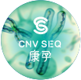

CNV-seq 染色体检测（康孕®)

CNV-seq Chromosome Sequencing

可检测 23 对染色体非整倍体，三倍体，100Kb 以上的缺失或重复、5 种单亲二体以及提示 宫内病原感染，用于排查自然流产、先天畸形、智力障碍、发育迟缓等疾病的遗传病因

Detect 23 pairs of chromosomal aneuploidy, ≥100Kb deletions/duplications, used to identify genetic causes of spontaneous abortion, congenital malformations, intellectual disabilities, developmental delays, and other diseases.

• 新生儿检测项目 Neonatal Testing



新生儿耳聋基因筛查（耳聆可 ®)

Newborn deafness gene screening (HearingCare)

通过采集新生宝宝微量血液，进行基因检测，评估得出宝宝患听力障碍的疾病风险

By collecting little amount of blood from newborn and conducting genetic testing, the risk of the newborn suffering from hearing impairment can be assessed.



新生儿遗传代谢病筛查

Newborn Metabolic Disease Screening

可以同时筛查包括氨基酸代谢缺陷、有机酸代谢缺陷和脂肪酸氧化障碍等在内的几十种 遗传代谢病，极大地扩展了筛查的疾病谱，大大提高了筛查效率。

Dozens of hereditary metabolic diseases, including amino acid metabolism defects, organic acid metabolism defects and fatty acid oxidation disorders can be screened at the same time, greatly expand the spectrum of diseases screened and greatly elevate screening efficiency.



新生儿遗传病基因筛查（安馨可 ®)

Newborn Genetic Disease Screening (AngelCare®)

常见遗传代谢病、耳聋、地中海贫血、杜氏肌营养不良、脊髓型肌肉萎缩症等 254 种疾病的 一站式筛查

One-stop screening for 254 diseases including common hereditary metabolic diseases, hereditary deafness, thalassemia, Duchenne muscular dystrophy, spinal muscular atrophy, etc.



新生儿先天性肾上腺皮质增生症检测

Newborn Congenital Adrenal Hyperplasia Testing

通过定量检测干血片样本中的 5 种类固醇激素，可有效降低 CAH 筛查的假阳性率，提高 阳性预测值

Quantitative detection of 5 steroid hormones in dried blood spots, effectively reduces the false positive rate of CAH screening and improves the positive predictive value.



新生儿溶酶体贮积症检测

Newborn Lysosomal Storage Disease Testing

通过同时测定干血片中相关溶酶体酶的活性，从而实现多种溶酶体贮积症 ( 如戈谢病等 ) 的 检测

By simultaneously measuring the activity of related lysosomal enzymes in dried blood spots, multiple

lysosomal storage diseases (such as Gaucher disease, etc.) can be detected.

• 单基因病检测项目 Monogenic Disease Testingt



单基因遗传病基因检测（觅因可 ®)

Monogenic Genetic Disease Testing (MonoGenix®)

常见单基因遗传病 panel、临床全外显子组检测及临床全基因组检测，立足于科学严谨的 基因组学研究和准确专业的临床检测技术，为单基因遗传病的临床诊断、治疗和突变筛查， 提供全面、准确、科学的检测服务。

Providing monogenic genetic disease testing, clinical whole-exome sequencing (WES), and clinical whole- genome sequencing (WGS) to detect and analyze all kinds of genetic diseases including chromosomal diseases, mitochondrial diseases, single-gene diseases and so on, to assist clinical diagnosis.



肿瘤防控及转化医学 Cancer Prevention and Control and Translational Medicine

• 预防 Monogenic Disease Testingt



遗传性肿瘤基因检测

Hereditary Cancer Genetic Testing

肿瘤风险早知道，未病先防保健康

Know the risk of cancer early and prevent the cancer from happening for keeping healthy.

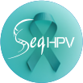HPV 分型检测 (SeqHPV®)

HPV Genotyping Testing(SeqHPV®)

通过采取女性阴道分泌物的宫颈脱落细胞样本，明确受检者感染何种 HPV、结合临床手段 及时发现中高度癌前病变并进行处理，可有效预防宫颈癌的发生

By taking samples of cervical exfoliated cells from female vaginal secretions, it is possible to identify which HPV type the subject is infected with, and to promptly detect and treat moderate to severe precancerous lesions using clinical methods, which can effectively prevent the occurrence of cervical cancer.

• 早筛 Monogenic Disease Testingt



肠癌 DNA 甲基化检测（华常康 ®)

Colorectal Cancer DNA Methylation Testing

通过体外定性检测人粪便样本中肠道脱落细胞的 SDC2、ADHFE1 和 PPP2R5C 基因的甲基化 情况，从而评估受检者罹患结直肠癌及进展期腺瘤的风险



The methylation level of SDC2, ADHFE1 and PPP2R5C genes in intestinal exfoliated cells in human fecal samples was qualitatively detected in vitro to assess the risk of colorectal cancer and advanced adenoma in the subjects.



宫颈癌 DNA 甲基化检测（华妍康 ®)

Cervical Cancer DNA Methylation Testing

检测宫颈脱落细胞中相关基因的甲基化，适用于高危 HPV 基因型检测阳性的女性人群， 帮助识别是否需要进行阴道镜检查，达到分流管理的作用

Detection of methylation of related genes in cervical exfoliated cells is suitable for women with positive high- risk HPV genotype test, helping to identify whether colposcopy is needed to achieve the role of diversion management.

• 伴随诊断 Companion Diagnostics



肺癌组织靶向用药基因检测（华翡冉 ®)

Lung cancer medication guidance

以非小细胞肺癌患者的肿瘤组织为样本，检测 50 个与非小细胞肺癌诊疗相关基因，为初诊 或一线、二线治疗耐药的非小细胞肺癌患者精准靶向治疗提供参考

Using tumor tissue samples from patients with non-small cell lung cancer, 50 genes related to non-small cell lung cancer treatment are tested at one time, providing a reference for precise targeted treatment of non-small cell lung cancer patients who are newly diagnosed or resistant to first-line or second-line treatment.



ctDNA 肺癌靶向药物基因检测（华翡悦®)

Lung cancer testing(ctDNA)

以非小细胞肺癌患者的外周血为样本，采用高通量测序技术，检测血液中循环肿瘤 DNA

(ctDNA)的 13 个基因的特定变异，为晚期非小细胞肺癌患者的靶向治疗提供参考信息

Using peripheral blood samples from patients with non-small cell lung cancer, high-throughput sequencing technology was used to detect specific mutations in 13 genes from circulating tumor DNA (ctDNA) in the blood, providing medication guidance for targeted treatment of patients with advanced non-small cell lung cancer.













HRD score 同源重组缺陷检测（华然迪 ®)

HRD score testing

同源重组修复通路是人体重要的 DNA 损伤修复通路之一，它主要行使着 DNA 双链断裂的 修复功能

The homologous recombination repair pathway is one of the important DNA damage repair pathways in the human body. It mainly repairs double-strand breaks in DNA.

同源重组信号通路基因检测（华然安 ®)

Homologous recombination signaling pathway gene detection

以肿瘤患者的肿瘤组织（石蜡切片）和 / 或者外周血为样本，检测包含 *BRCA1/2* 在内的 68 个同源重组信号通路基因，是一款专门针对 PARP 抑制剂疗效评估和相关遗传性肿瘤 综合征风险评估的检测产品

The test uses tumor tissue (paraffin sections) and/or peripheral blood of cancer patients as samples to detect 68 homologous recombination signaling pathway genes including BRCA1/2. The product specifically for evaluating the efficacy of PARP inhibitors and the risk assessment of related hereditary tumor syndromes.

子宫内膜癌基因检测（华妍安 ®)

Endometrial cancer gene testing

通过检测患者的肿瘤组织和外周血样本，可一次性得到子宫内膜癌的分子分型、遗传风险 评估、靶向和免疫治疗药物参考，快速、准确地评估患者的预后、辅助治疗参考方案、患者 及家人的遗传风险，给患者和临床医生提供全方位的精准诊疗解决方案

By testing the patient's tumor tissue and peripheral blood samples, obtaining the molecular typing, genetic risk assessment, targeted therapy medication guidance and immunotherapy medication guidance results of endometrial cancer, which is conducive to quickly and accurately assessing the patient's prognosis, adjuvant treatment reference plan, and the genetic risks of the patient and his family, providing patients and clinicians with a full range of precision diagnosis and treatment solutions.

肠癌组织靶向用药基因检测（华常安 ®)

S Colorectal cancer medication guidance

以结直肠癌患者的肿瘤组织为样本，检测与结直肠癌靶向用药相关的 23 个基因，为拟进 行靶向治疗的结直肠癌患者提供用药参考信息

Using the tumor tissue of colorectal cancer patients as samples, 23 genes related to colorectal cancer targeted drugs are detected to provide drug reference information for colorectal cancer patients who intend to undergo targeted treatment.

肿瘤个体化诊疗基因检测（华泛安 ®)

Cancer discovery panel

解决靶向用药、免疫治疗、化疗药物、遗传风险、分子分型、耐药检测六大临床需求， 根据每个样本的检测情况提供全方位、精准的解读，协助医生制定更完善的治疗方案

Solve clinical needs such as targeted medication guidance, immunotherapy medication guidance, chemotherapy medication guidance, genetic risk assessment, molecular typing, and finding the cause of drug resistance, and provide a comprehensive and accurate interpretation based on the test results of each sample to assist doctors in formulating a more complete treatment plan.

肿瘤全外显子基因检测（全希 ®)

Cancer WES NEO

检测近 2 万个基因的全部外显子区域和部分内含子区域，重点解读与实体瘤诊疗相关的 689 个基因，为实体瘤患者提供全面的靶向治疗、免疫治疗、化疗的用药参考， 以及肿瘤 相关的遗传风险评估

SentisTM Cancer WES cover all exon regions and partial intron regions of nearly 20,000 genes, focusing on interpreting 689 genes related to the diagnosis and treatment of solid tumors, providing patients with solid tumors with comprehensive medication references for targeted therapy, immunotherapy, chemotherapy, and tumor-related genetic risk assessment.

• 复发监测 Recurrence monitoring

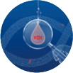肿瘤 MRD 定制化检测（华见微®)

Tumor MRD customized testing

采用引进的 Signatera MRD 检测技术，对肿瘤患者的肿瘤病灶进行全外显子测序(WES)，根据 每位患者的自身的 WES 突变情况定制专属监测 panel，采用定制的 panel 对外周血样本进行 约10万X超高测序深度的 ctDNA 检测，用于肿瘤患者的分子残留病灶(MRD)评估、预后预测、 复发风险评估、治疗疗效监测。该检测适用于 IIA 期及以上泛实体瘤患者（脑部肿瘤或脑 转移除外）的全病程监测

Signatera MRD detection technology was introduced to perform whole exome sequencing (WES) on tumor lesions of tumor patients. the monitoring panel was customized according to whole exome sequencing data of each patient. The customized panel was used to perform about 100,000X sequencing depth sequencing on peripheral blood samples for molecular residual lesion (MRD) assessment, prognosis prediction, recurrence risk assessment, and treatment efficacy monitoring of tumor patients. This test is suitable for full-course monitoring of patients with pan-solid tumors at stage IIA and above (except brain tumors or brain metastases).



传感染防控 Infection Prevention and Control



病原微生物高通量基因检测 (PMseq®)

Pathogen Metagenomic Sequencing (PMseq®)

基于宏基因组测序(mNGS)技术，提取临床感染标本全部核酸，进行高通量测序，通过 微生物专用数据库比对和智能化算法分析，获得疑似致病微生物的种属信息。一次性可检测 上万种病原微生物及代表性耐药和毒力基因，为疑难危重感染提供快速精准诊断依据，促进 抗生素的合理应用

Based on metagenomic sequencing technology, all nucleic acids of clinical infection samples are extracted and high-throughput sequencing is performed. Through microbial database comparison and intelligent algorithm analysis, the species information of suspected pathogenic microorganisms was obtained. It can detect tens of thousands of pathogenic microorganisms and representative drug resistance and virulence genes at one time. It provides a basis for rapid and accurate diagnosis of difficult and critical infections, and promote the rational application of antibiotics.

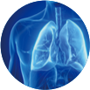

病原微生物靶向高通量检测技术 (PTseqTM)

Pathogen Targeted Gene Sequencing (PTseqTM)

基于靶向高通量测序(Targeted Next-Generation Sequencing，tNGS)技术，提取感染样本中 全部核酸，通过超多重 PCR 扩增或探针杂交捕获技术，富集特定区域(Regions of Interest， ROI)的靶标序列后，进行高通量测序，进而完成病原微生物及耐药基因等鉴定

Based on Targeted Next-Generation Sequencing (tNGS) technology, all nucleic acids of infection samples are extracted, and then enriched with target sequences in specific regions of interest (ROI) by ultra-multiplex PCR amplification or probe hybridization capture technology, and then subjected to high-throughput sequencing, so that the identification of pathogenic microorganisms and drug-resistant genes can be accomplished.

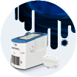全自动医用 PCR 分析仪 (PM Easy Lab®)

Pathogen Multiplex Nucleic Acid Testing (PM Easy Lab®)

PM Easy Lab 全自动医用 PCR 分析仪是全自动设备，采用多重荧光 PCR 法，配套微流控 技术的核酸提取卡匣和多重核酸检测卡匣进行检测，适用于住院症候群感染快速查 ; 可真正 实现“提取 - 扩增- 报告”一体化

PM Easy Lab is a medical fully automated nucleic acid analysis system , using multiplex fluorescence PCR method, equipped with microfluidic nucleic acid extraction cassette and multiplex nucleic acid detection cassette, which is suitable for rapid detection of hospitalization syndrome infection. It can truly realize the integration of "extraction - amplification - report".



慢病防控 Infection Prevention and Control

• 风险评估 Risk Assessment

遗传性心血管疾病基因检测

Hereditary Cardiovascular Disease Genetic Testing

涵盖国内外多部指南和专家共识中的八大类单基因遗传性心血管疾病，提供专业的基因 检测报告和全方位的遗传咨询服务，辅助临床进行精准诊断。制定合理的治疗方案

It covers eight categories of monogenic hereditary cardiovascular disease as outlined in multiple domestic and international guidelines and expert consensus, provides professional gene testing reports and a full range of genetic counseling services, and assists in clinical accurate diagnosis. Formulate reasonable treatment plans.

早发冠心病风险基因检测

Early-onset Coronary Heart Disease Risk Genetic Testing

通过对血脂异常人群进行早发冠心病风险基因检测可以针对疾病早发现早干预，实现 慢性病“防大于治”的管理目标，并且通过药物基因检测降低他汀类药物不良反应风险

Through genetic testing of the risk of early coronary heart disease in people with dyslipidemia, early detection and early intervention of the disease can be achieved, fulfilling the management goal of "prevention is better than cure" for chronic diseases, and reducing the risk of adverse reactions to statins through drug genetic testing.

同型半胱氨酸代谢通路检测

Homocysteine Metabolism Pathway Testing

同型半胱氨酸水平过高与高血压、心脑血管疾病、神经系统疾病、肿瘤等密切相关。通过 一次性测定血清样本中同型半胱氨酸及其代谢通路相关指标水平，通过针对性的精准 干预措施，有效降低受检者体内同型半胱氨酸水平

Hyperhomocysteinemia is significantly correlated with a range of conditions, including hypertension, cardiovascular and cerebrovascular diseases, neurological disorders, malignancies. A one-time assessment of serum homocysteine concentrations and related metabolic pathway indicators, coupled with targeted and precise intervention strategies, can effectively reduce the elevated homocysteine levels within the examined individuals.

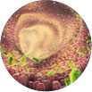氧化三甲胺代谢通路检测

Trimethylamine N-oxide (TMAO) Metabolic Pathway Testing

氧化三甲胺（TMAO）是一种肠源性菌群代谢物，是心脑血管疾病和其他慢性疾病的潜在 风险因子。通过同时检测血清中 TMAO 和 3 种 TMAO 膳食前体物质，评估受检者心脑血管 疾病的风险，指导受检者的肠道菌群和短期膳食结构调节

Trimethylamine N-oxide (TMAO) is a gut microbiota-derived metabolite and a potential risk factor for cardiovascular and cerebrovascular diseases, as well as other chronic diseases. Assessing the serum concentrations of TMAO alongside its three dietary precursors simultaneously enables the evaluation of the risk for cardiovascular and cerebrovascular diseases among the examined individuals. This assessment can inform strategies for modulating their gut microbiota and short-term dietary patterns.

多种神经酰胺检测

Multiple Ceramide Testing

神经酰胺是复杂的脂质，神经酰胺浓度升高与动脉粥样硬化斑块形成、缺血性心脏病、 心肌梗塞、高血压、中风、2 型糖尿病、胰岛素抵抗和肥胖有关。通过神经酰胺及其比值 进行风险评分计算，可评估受检者心脑血管疾病的发生风险

Ceramides are complex lipids, and elevated ceramide concentrations are associated with the formation of atherosclerotic plaques, ischemic heart disease, myocardial infarction, hypertension, stroke, type 2 diabetes mellitus, insulin resistance, and obesity. By calculating risk scores based on ceramide levels and their ratios, the risk of cardiovascular and cerebrovascular diseases in the examined individuals can be assessed.



认知障碍疾病基因检测

Cognitive Impairment Diseases Genetic Testing

检测多种认知障碍疾病相关的 323 个致病基因和风险基因，可以帮助患者确定遗传性 病因，有助于疾病诊断、病情判断和疾病管理，同时可以提示家族遗传情况，有利于帮助 亲属判断风险并提前干预，从而降低发病风险

Detecting 323 pathogenic genes and risk genes related to various cognitive impairment diseases can help patients determine the genetic cause, facilitate disease diagnosis, condition assessment and disease management, and indicate family genetic conditions, which is helpful for relatives to judge risks and intervene in advance,thereby reducing the risk of disease.

• 精准用药 Precision Medicine



心血管疾病药物基因检测（快速版）

Cardiovascular disease drug gene testing

对 4 类临床常用药物的相关基因的多态性位点进行检测和分析，有助于临床用药走出尝试、 观察和调整的传统框架，指导临床个体化用药，优化用药剂量，增强疗效，减少药物 不良反应事件

Detection and analysis of polymorphic sites of genes related to four types of commonly used clinical drugs will help clinical drug use to move beyond the traditional framework of trial, observation and adjustment, guide clinical individualized drug use, optimize drug dosage, enhance efficacy and reduce adverse drug reaction events.



个体化用药指导基因检测系列（安觅方®)

Individualized chronic disease medication guidance

基于现有基因多态性对药物疗效及不良反应影响的相关研究，结合受检者基因多态性 变异情况，为临床安全、有效用药提供参考建议

Based on the existing research on the effects of gene polymorphism on drug efficacy and adverse reactions, combined with the gene polymorphism variation of the subjects, provide reference suggestions for safe and effective clinical drug use.

• 营养代谢 Nutrient Metabolism



精准营养与代谢检测

Precision Nutritional and Metabolic Testing

通过高效液相色谱 - 串联质谱（简称 LC-MS/MS）和电感耦合等离子体质谱（简称 ICP- MS）技术分别对受检者体内多种维生素、氨基酸、类固醇激素、儿茶酚胺及其代谢物、 胆汁酸、微量元素、重金属元素等进行定量分析， 评估人体营养及代谢状态，为疾病预防、 辅助诊断、疾病预后等提供帮助

Utilizing High-Performance Liquid Chromatography-Tandem Mass Spectrometry (LC-MS/MS) and Inductively Coupled Plasma Mass Spectrometry (ICP-MS) technologies, to assess the nutritional and metabolic status of the examined individuals. The quantitative analysis of the concentrations of various nutrients and metabolites, including multiple vitamins, amino acids, steroid hormones, catecholamines and their metabolites, bile acids, trace elements, and heavy metal elements in the biological samples, provides support for disease prevention, auxiliary diagnosis, and disease prognosis.

全球分布 Global Presence

华大基因总部位于中国·深圳，业务覆盖全球超过 100 个国家和地区。

BGI is headquartered in Shenzhen, China, with services and solutions available in more than 100 countries and regions around the world.

瑞典斯德哥尔摩

Stockholm, Sweden

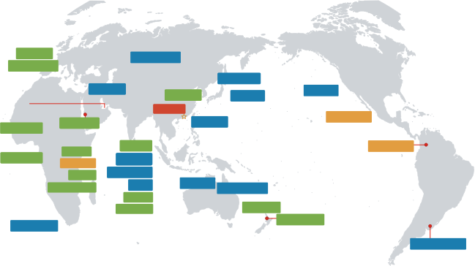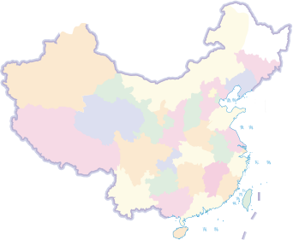

波兰华沙

Warsaw, Poland

德国柏林

Berlin, Germany

拉脱维亚里加

Riga, Latvia

德国法兰克福 

Frankfurt, Germany

荷兰鹿特丹

Rotterdam, Netherlands

o 土nl斯,T尔   

法国巴黎 

Paris, France 

阿塞拜疆巴库

Baku, Azerbaijan

哈萨克斯坦阿拉木图

Almaty, Kazakhstan

匈牙利布达佩斯  韩国首尔

乌兹别克斯坦塔什干

Tashkent, Uzbekistan

Budapest，Hungary Seoul, South Korea

 阿联酋迪拜 美国圣何塞 

塞尔维亚贝尔格莱德

Belgrade，Serbia

印度新德里

New Delhi, India

Dubai, UAE 印度海德拉巴 日本东京 San Jose, USA

Hyderabad, India Tokyo, Japan

阿联酋阿布扎比

Abu Dhabi, UAE

中国深圳

Shenzhen, China

多米尼加圣多明各

Santo Domingo, Dominica

Kobe, Japan

沙特利雅得

Riyadh, Saudi Arabia

墨西哥墨西哥城   

Mexico City, Mexico

老挝万象

Vientiane, Laos

沙特吉达

Jeddah, Saudi Arabia

科威特科威特城

Kuwait City, Kuwait

菲律宾马尼拉

Manila, Philippines

埃塞俄比亚亚的斯亚贝巴

Addis Ababa，Ethiopia

越南河内

Hanoi, Vietnam

泰国曼谷

Bangkok, Thailand

马来西亚吉隆坡

Kuala Lumpur, Malaysia

新加坡

tá亚,Ci

越南胡志明市

Ho Chi Minh City, Vietnam

卡塔尔多哈

Doha, Qatar

印度班加罗尔

以色列特拉维夫

Tel Aviv, Israel

文莱斯里巴加湾市

Bandar Seri Begawan，Brunei

Bangalore, India

印度孟买

Mumbai,India

巴基斯坦伊斯兰堡

Islamabad, Pakistan

印尼雅加达

Jakarta, Indonesia

澳大利亚布里斯班

Brisbane, Australia

Singapore

印度金奈

Chennai, India

孟加拉达卡

澳大利亚阿德莱德

Adelaide, Australia

澳大利亚悉尼

Sydney, Australia

Dhaka, Bangladesh

新西兰奥克兰

Auckland, New Zealand

巴西圣保罗

Sao Paulo, Brazil

南非开普敦

CapeTown, South Africa

澳大利亚墨尔本

Melbourne, Australia

新西兰但尼丁

New Zealand, Dunedin

乌拉圭蒙得维的亚

Montevideo, Uruguay

本溪 Benxi

石家庄 Shijiazhuang



总部 Headquarters

办事处/实验室 Office/Lab

代表处 Representative Office

在建 Future Plan

贵阳

Guiyang

昆明 Kunming

海口

Haikou









郑州

Zhengzhou

新乡

Xinxiang





上海

Shanghai

杭州

Hangzhou

南昌

Nanchang

哈尔滨 Haerbin

北京

长春 Changchun

Beijing

鄂尔多斯 Eerduosi

天津 Tianjin

青岛 Qingdao

呼和浩特 Hohhot

济南 Jinan

临沂 Linyi

兰州 Lanzhou

西安 Xi'an

泰安 Taian

拉萨 Lasa

重庆

Chongqing

武汉 Wuhan

成都 Chengdu

南京 Nanjing

福州

益阳 Yiyang

Fuzhou

长沙

常州

Changzhou

Changsha

东莞

昆山 Kunshan

Dongguan

广州 Guangzhou

香港 Hong Kong

南宁 Nanning

珠海

三亚 Sanya

Zhuhai

深圳 Shenzhen

丹麦哥本哈根

Copenhagen, Denmark

全满贯合规资质 国际级评审认证 Full Qualifications, Certified by International Jury

华大基因竭诚为您提供可信赖检测服务

BGI Genomics wholeheartedly provides you with reliable testing services.

医疗器械药监权威获批

medical device approved by the National Medical Products Administration

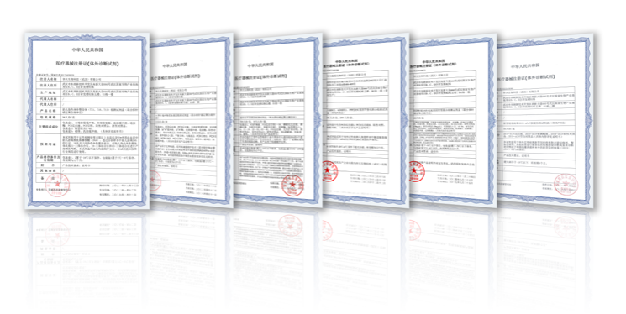

* 节选自部分医疗器械注册证书

国际实验室能力认可

Capabilities of the international lab approved

医疗机构执业许可

Medical Institution License

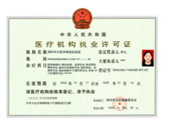

仅供宣传使用

仅供招投标使用

|  |
| --- |
|  |



* 节选自部分医疗机构执业许可证书

全国实验室室间质评

Passed External Quality Assessment By National Lab



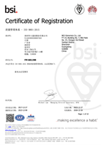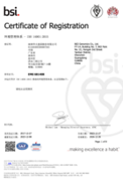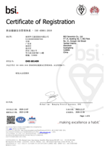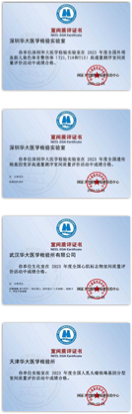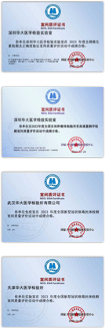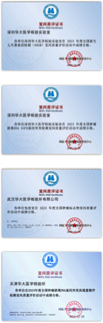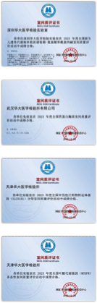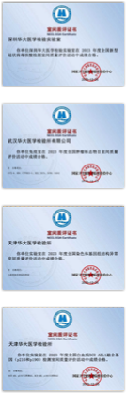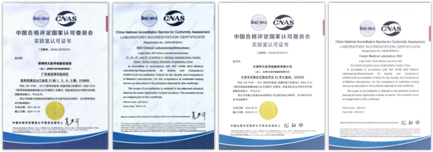



此为证书 CN16/30444.03 译本

**深圳华大基因股份有限公司**

统一社会信用代码: 914403005586967563

注册地址 : 中国广东省深圳市盐田区洪安三街 21 号华大综合园 7 栋 7-14 层

经营地址 : 中国广东省深圳市盐田区梅沙街道云华路 9 号华大时空中心 B 栋 8 层

依据主证书 CN16/30444.00 中规定的管理体系已经过审核，并被证明符合下述要求 **ISO/IEC** **27001:2022**

所涉及的活动范围覆盖

1、提供基因检测服务（含产前筛查基因检测、遗传病基因检测、胚胎植入前遗传学检测、肿瘤基因检测、

常见病原体快速检测、血液病基因检测、个体化用药指导基因检测、新型冠状病毒核酸检测、低深度全基因 组测序（CNV-seq）检测、高通量测序服务）

2、提供质谱检测服务（含新生儿遗传代谢病检测、代谢物检测、微量元素和重金属检测）

3、提供生物信息分析服务

依据适用性声明（B 版）进行评估

该证书的有效期自 2024 年 07 月 22 日 至 2027 年 07 月 21 日 并须经过符合要求的监督审核保持有效 版本号 8.

此证书的有效性取决于主证书的有效性.



签署

Jonathan Hall Global Head -

Certification Services SGS United Kingdom Ltd

Rossmore Business Park, Ellesmere Port, Cheshire, CH65 3EN, UK t +44 (0)151 350-6666 - www.sgs.com



本文件是真实的电子版证书, 仅供客户用于其商业用途。客户可自行打印, 视同副本。本文件根据Terms and Conditions | SGS 中认证服务通用条款的要求颁发。提请注意其中已包含的责任范围, 赔偿和司法管辖事项。本文件受 SGS 版权保护, 任何未经授 权的对此文件的内容或外观的变更, 伪造或篡改皆属非法。

第 1 页共 1 页



* 节选自部分实验室能力认可证书 * 节选自部分实验室室间质评证书

社会责任 Social Responsibility

“想中央之所想，急人民之所急，办抗病之所需”

Align with central government's needs, fight against epidemic emergency and meet people's needs

（2003 年胡锦涛同志视察华大基因时对华大基因科研人员的评价） （CPC Secretary General Hu Jingtao commended BGI when visiting BGI in 2003）

公共卫生

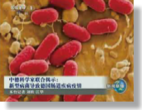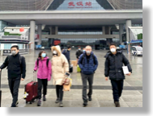Public Health

“德国大肠杆菌疫情”战役

抗击新型冠状病毒肺炎疫情

Fight against COVID-19



抗击“非典”

Fight against Deadly E. Coli Epidemic in Germany

Fight against SARS

抗灾

Disaster Relief

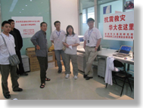

印度洋海啸遇难人员 DNA 鉴定 DNA Identification of the Indian Ocean Tsunami Victims

汶川地震灾后疫情监测

Disease Surveillance after Wenchuan Earthquake

民生

Livelihood Improvement

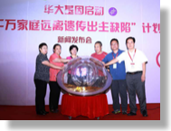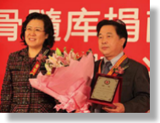

“千万家庭远离遗传出生缺陷 " 计划 Genetic Birth Defect Prevention for Tens of Thousands of Families Program

捐献“中华骨髓库”

The Chinese Marrow Donor Program（CMDP）

公益基金 Charitable Foundation

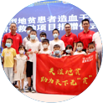

天下无贫公益基金于 2022 年正式成立，该公益专项以地中海贫血、镰刀型贫血等血红 蛋白病的防治救助为目的，帮助重型地贫患者开展造血干细胞移植及基因治疗的救助， 最终实现天下无“贫”（地贫、镰贫）的愿景。

The World Hemoglboinopathy Foundation was officially established in 2022. It is a public welfare special project that aims to prevent and treat hemoglobin diseases such as thalassemia and sickle cell anemia, thus helping patients with severe thalassemia receive hematopoietic stem cell transplantation and gene therapy, and ultimately achieving the vision of a world without thalassemia and sickle cell anemia.



光基金由华大基因 7 位女高管自发捐款成立，为全球范围内 14 岁以下的 LCA 临床确诊 或疑似患者提供免费的基因检测，帮助患者得到相应的医学救助。光基金的发起人们坚 信只有当越来越多的人关注罕见病，才可能有更多的科研和临床研究资源投入其中，才 可能让患者们有机会享受到可企及可负担的检测和后续治疗。

The Light Fund was established through voluntary donations from seven female executives of BGI Genomics. It provides free genetic testing for clinically diagnosed or suspected LCA patients under the age of 14 years worldwide, helping patients have access to corresponding medical assistance. The initiators of the Light Fund steadfastly believe that only when increasing people pay attention to rare diseases, can more scientific and clinical research resources be invested, and patients have the opportunity to enjoy accessible and affordable testing and subsequent treatment.

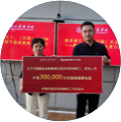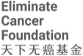

发现一例早癌，挽救一个生命，幸福一个家庭。人类与癌症的斗争从未停止过，但癌症预 防远远大于治疗，2022 年“天下无癌”公益专项正式启航，希望加快国产自主、科学高 效的防癌抗癌技术成果应用，推进普惠式癌症筛查防控，让更多人受益于科技进步，远离 癌症。

By discovering a case of early cancer, we can save a life and bring happiness to a family. The struggle between humanity and cancer has never ceased, but cancer prevention far outweighs treatment. In 2022, the “ Eliminate Cancer” public welfare project was officially launched, in a bid to accelerate the application of domestically independent, scientific and efficient cancer prevention and control technologies, promote inclusive cancer screening and control, and allow more people to benefit from technological progress and stay away from cancer.





华大医学



|  |
| --- |
| 华大基 |

访问华大基因官网 获取最新公司资讯

扫码关注华大医学 了解最新产品动态

服务热线： 400-605-6655

网 址： www.bgi.com

邮 箱： info@genomics.cn

地 址： 深圳市盐田区梅沙街道云华路9号华大时空中心

版 次： 2024年09月版

本手册仅供客户学习、交流和研究使用，请勿用于商业用途，违者必究。

版权声明：本手册版权属于深圳华大基因股份有限公司所有，未经本公司书面许可，任何其他个人或组织均不得以任何形式将本册中的各项内容进行 复制、拷贝、编辑或翻译为其他语言。本手册中所有商标或标志均属于深圳华大基因股份有限公司及其提供者所有。